**SAAS Explainer Document**

**Key points**

**License –** We start with one license type, The software checks for the license code at every use, it must be fully encrypted and hard to hack. So my VPS server has the website on and also some license server (we can check into what to use). The user has a login. One license can only be logged in with one session. So to prevent users sharing the login with friends, + also to log IP address of users in admin .

I have made software simpler to start with. To do core function.

*Allow user to run multiple tabs inside the multibrowse software, that all have their own instances of the browser inside, using proxies to pretend to be a different person with each tab. Store these profiles and projects in an ordered way so user can just click one, fire up their default browser instance (90% use will be Chrome after doing some questionaires to people).If it is much easier we can just focus on using Chrome to start. Each ‘profile’ instance must have a different browser footprint. (as they MUST be different people and computers from the point of view of the website, like facebook and google)*

***PAGE EXPLANATIONS***

User clicks the desktop icon for multibrowse (will send logo and icon) and it launches with a login popup with background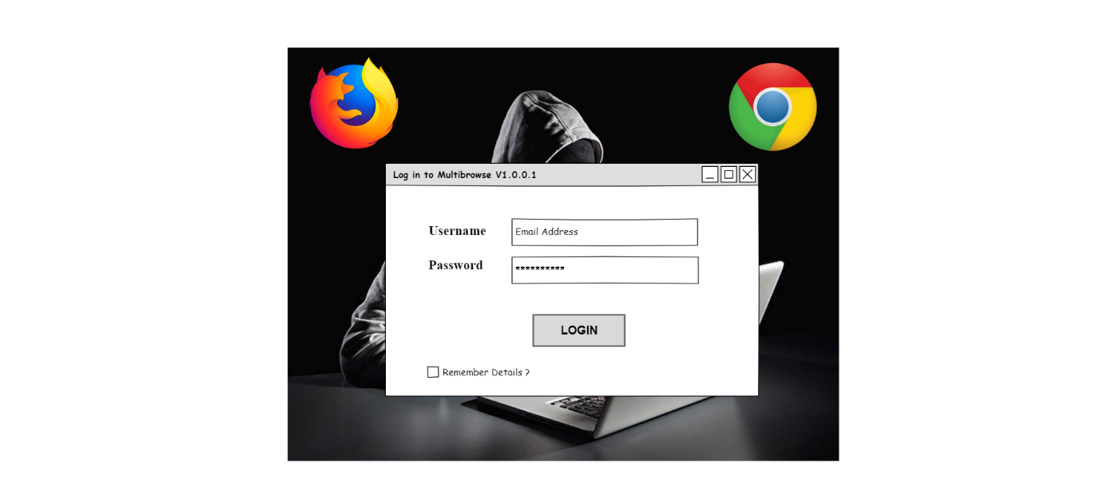

The license check calls the server (my server) end to end encryption and checks if this user has a valid license to use the software. If the server does not responds with Valid License, the software shutsdown after this window opens. Research best way to make it very secure that it doesn’t get disassembled and a crack made…

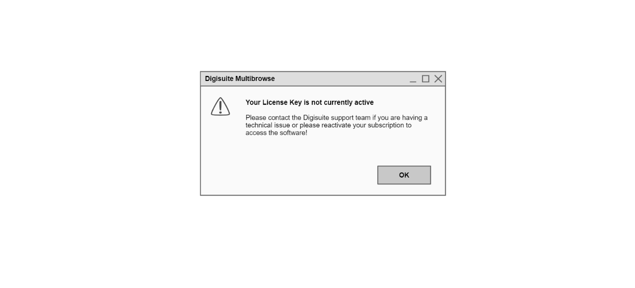

Main window – The user lands here after successful login. The tree structure   
on the left is for Projects and Profiles. A Project (or subproject) is basically a storage folder for Profiles. The user names it, and it is then used to help them arrange their profiles.  
A profile or ‘persona’ is the instance that will become, as far as the internet sees it, *different people*. So each profile has information stored against it (see the picture later on) that is about the ‘person’ that the profile is. Users in Digital marketing can use Profiles to login and appear to be ‘different’ people to facebook, google accounts, twitter and more. It also allows totally *anonymous browsing*. File tree needs to be fast drag and drop. So user can move profiles into new projects, and re order projects in the list, also can make a project a subproject by drag and drop.

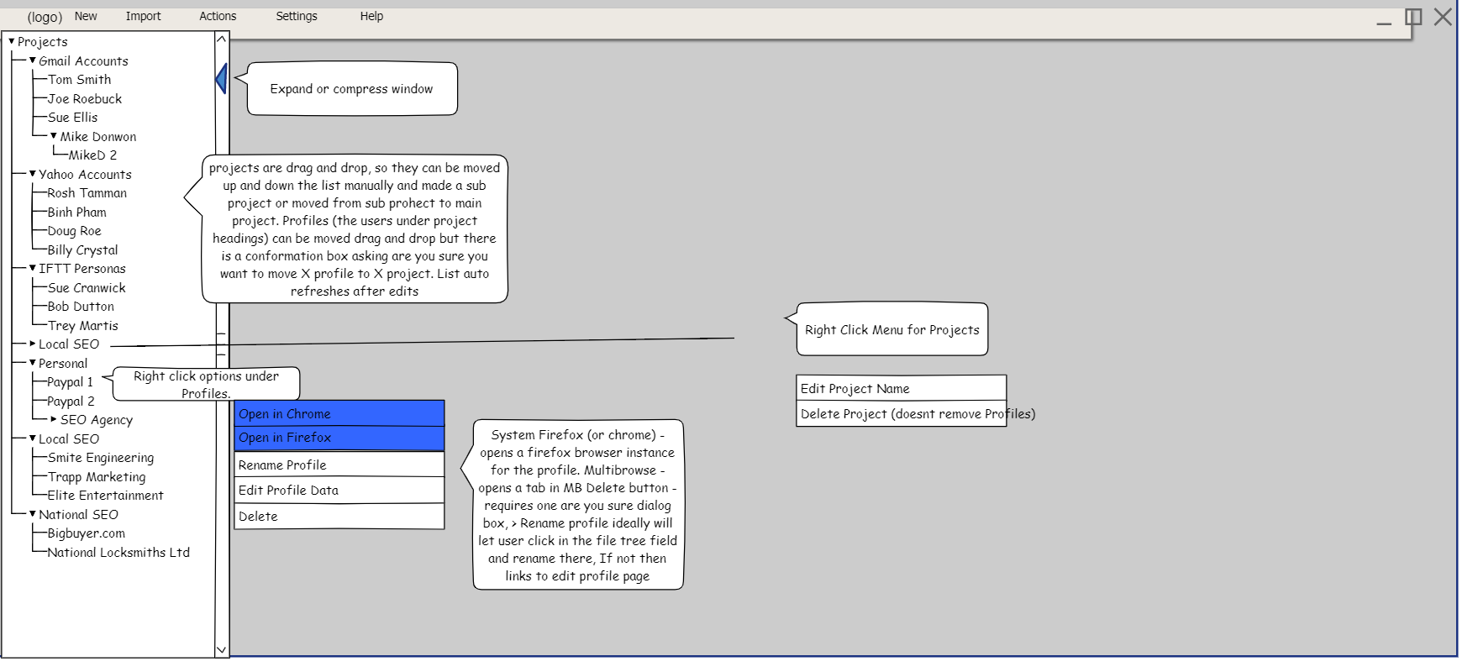

‘New men’ shows the two items on it. ‘Create a New Project’ and ‘Create a New Profile’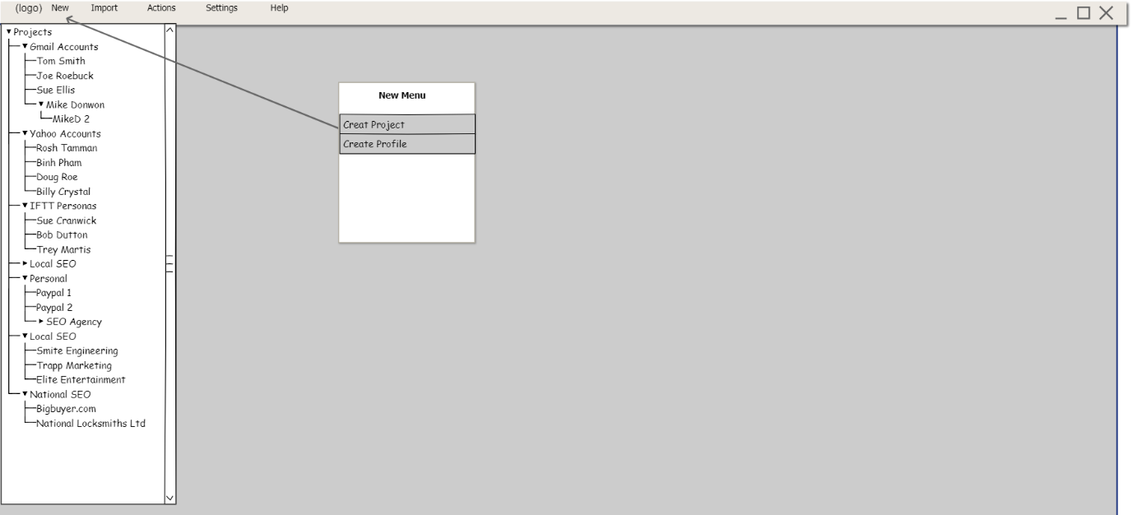

When ‘create project’ is clicked it will open this box (or one with these functions and style). User will type a ‘project Name’ , then select from dropdown if it is to be a sub project, then select an ‘Order’ so like in Opencart if it’s a main project and order is 2 it will be second project on list (like Yahoo Accounts). Create it button adds project to file tree but keeps popup open for if they want to add more. Then when they are finished they click X to close window.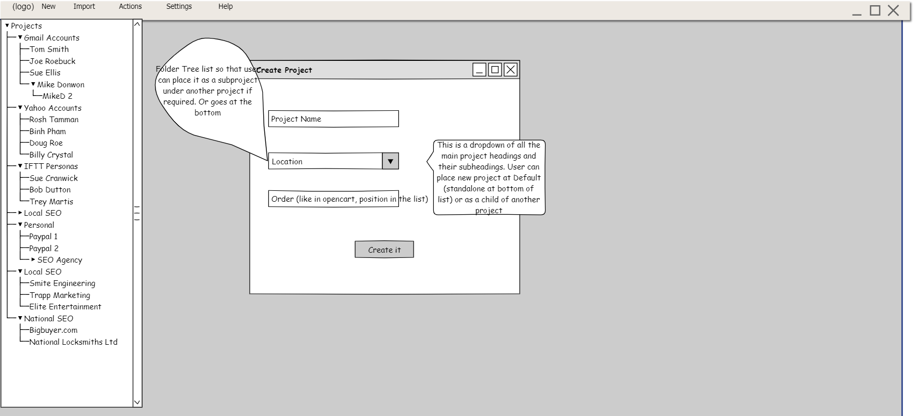

To create profile they can use Menus. New > profile, this opens. They add details for profile. Click create it. As above, profile is created and added in Project Tree , window remains open so user can add more profiles or close window with X.

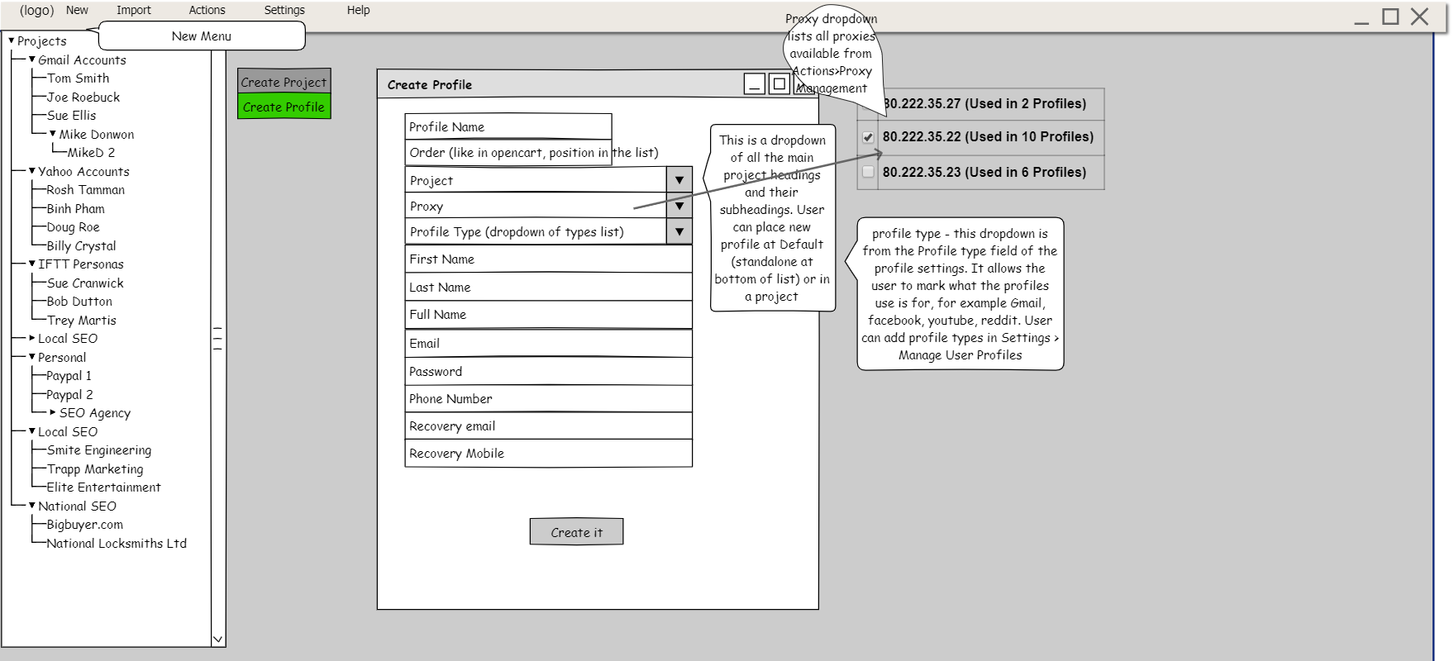

This is Edit Profile dialog box, when in main dashboard area, they can right click on a profile to edit it (from dropdown menu) this menu is shown on image Main Dashboard (first image shown after successful login). They can edit profile fields and dropdowns here and also select to delete a profile. If they want to delete, use the same method and dialog box as shown in Actions Menu > all profiles report

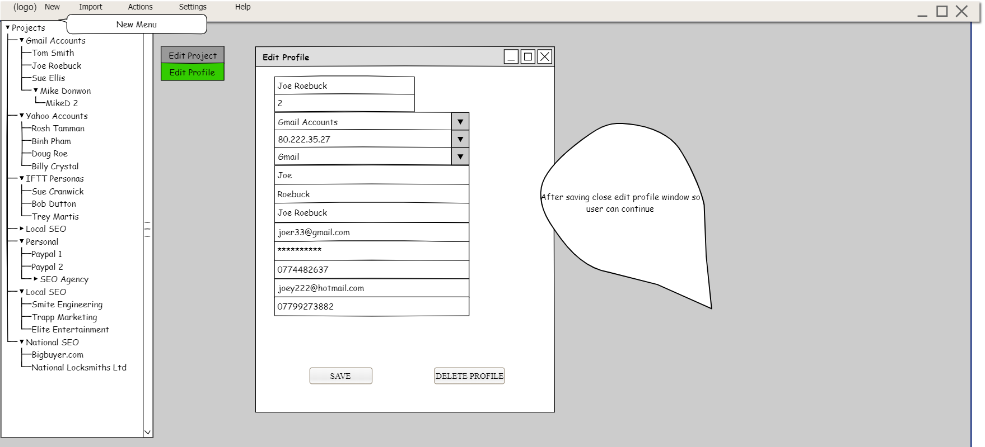

If user right clicks a project in Main Dashboard view, and selects edit project or delete, it takes them to this , where they can edit or delete that project. If project is deleted, it is a double confirm and warns them that all subprojects will be deleted. We should then place profiles at the bottom of the tree and not delete them from projects. Then user can drag them under another project(s)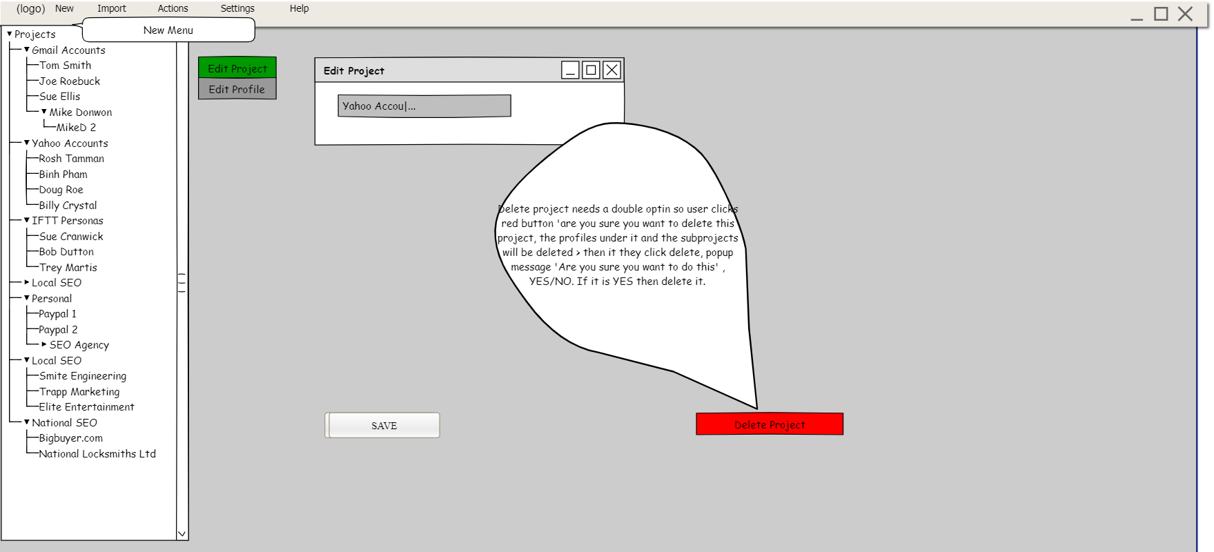

This shows after project is deleted and returns to main dashboard view

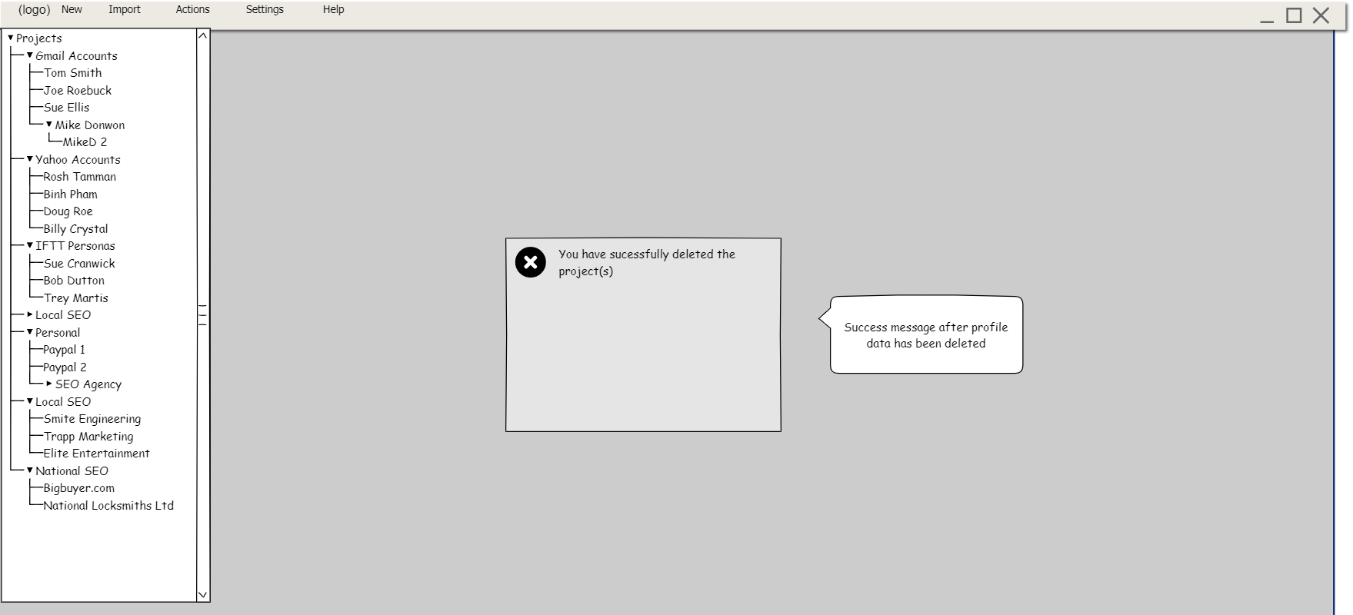

Next menu. Import Menu. From here we can select to import accounts or import an MB (Multibrowse) backup .. These are all CSV files.

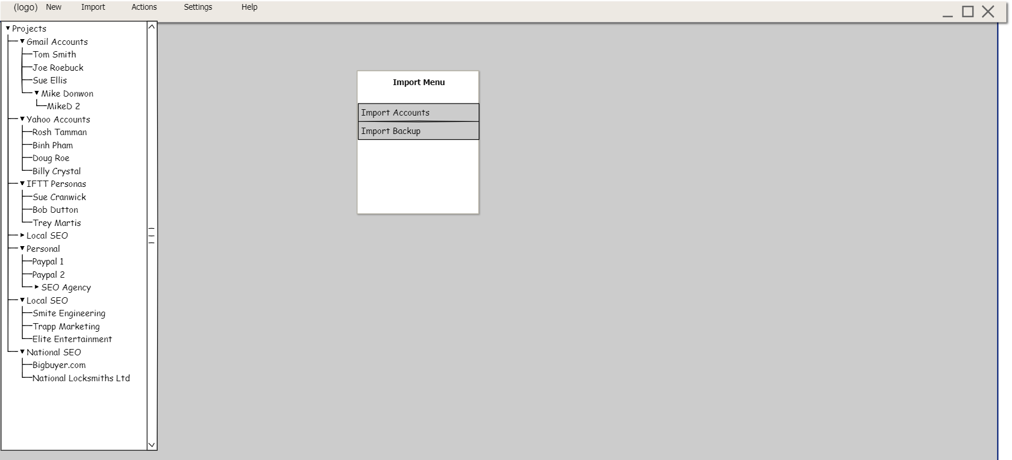

This is the Import Accounts menu. They will all be csv files in the format we need. I enclose a Gmail CSV file and a Browzio CSV file. Use will have to trim unrequired fields from browzio csv to match our Profile table fields .First button imports Browzio csv and adds the data to new Profiles. The same thing is done with Gmail CSV (except it only has gmail account data.). Import accounts CSV is a backup of accounts from multibrowse (see two images below for this)

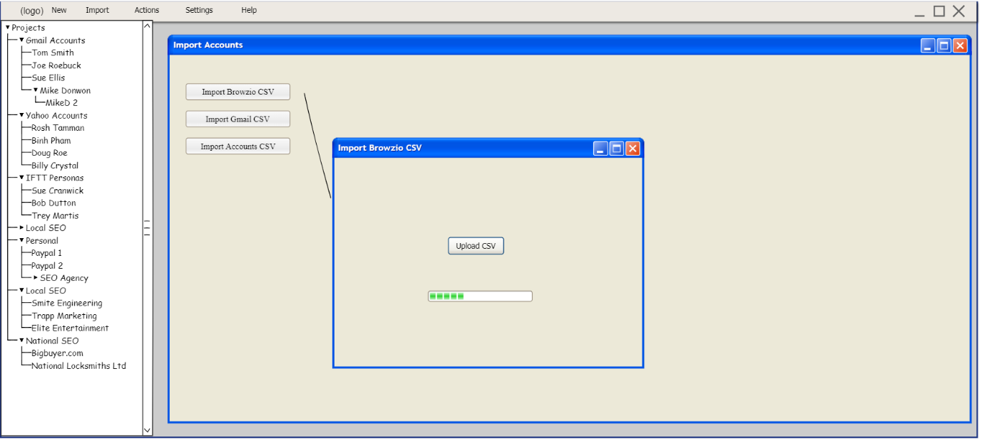

Import accounts from Browzio or Gmail csv takes you to this, so csv data is populated into new profile data rows. There could be fore example 10 profiles in the import. User can choose to save as they are, or select proxy to each on individually or apply random proxies to them, They can also add it to a profile type so they could for example make Gmail accounts in a profile type they made called Gmail accounts. Then they save.

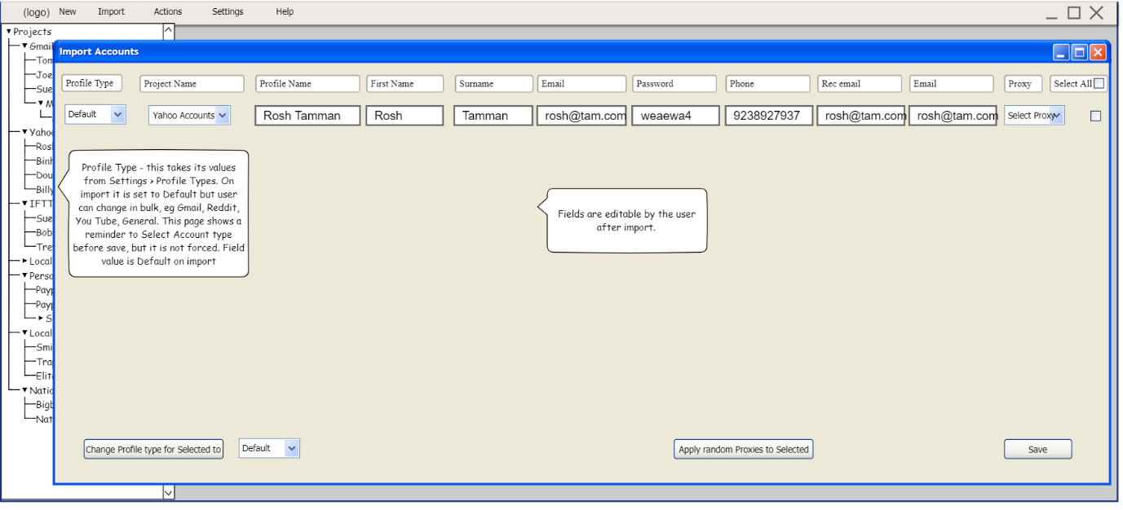

This is what they get if they choose to import multibrowse backup. If the database is not empty it gives them Import Failed, if records created successfully it shows success and returns to main dashboard.

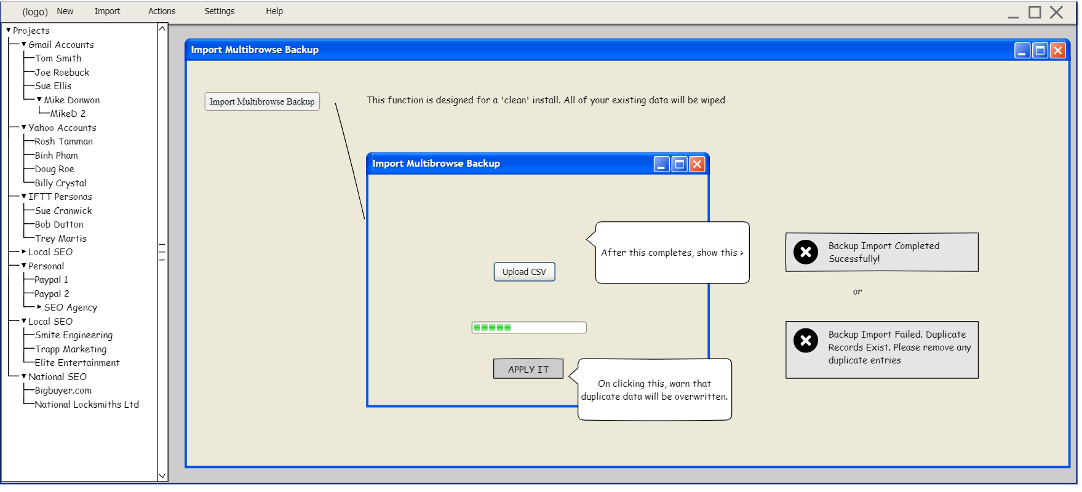

This is the actions menu and its items.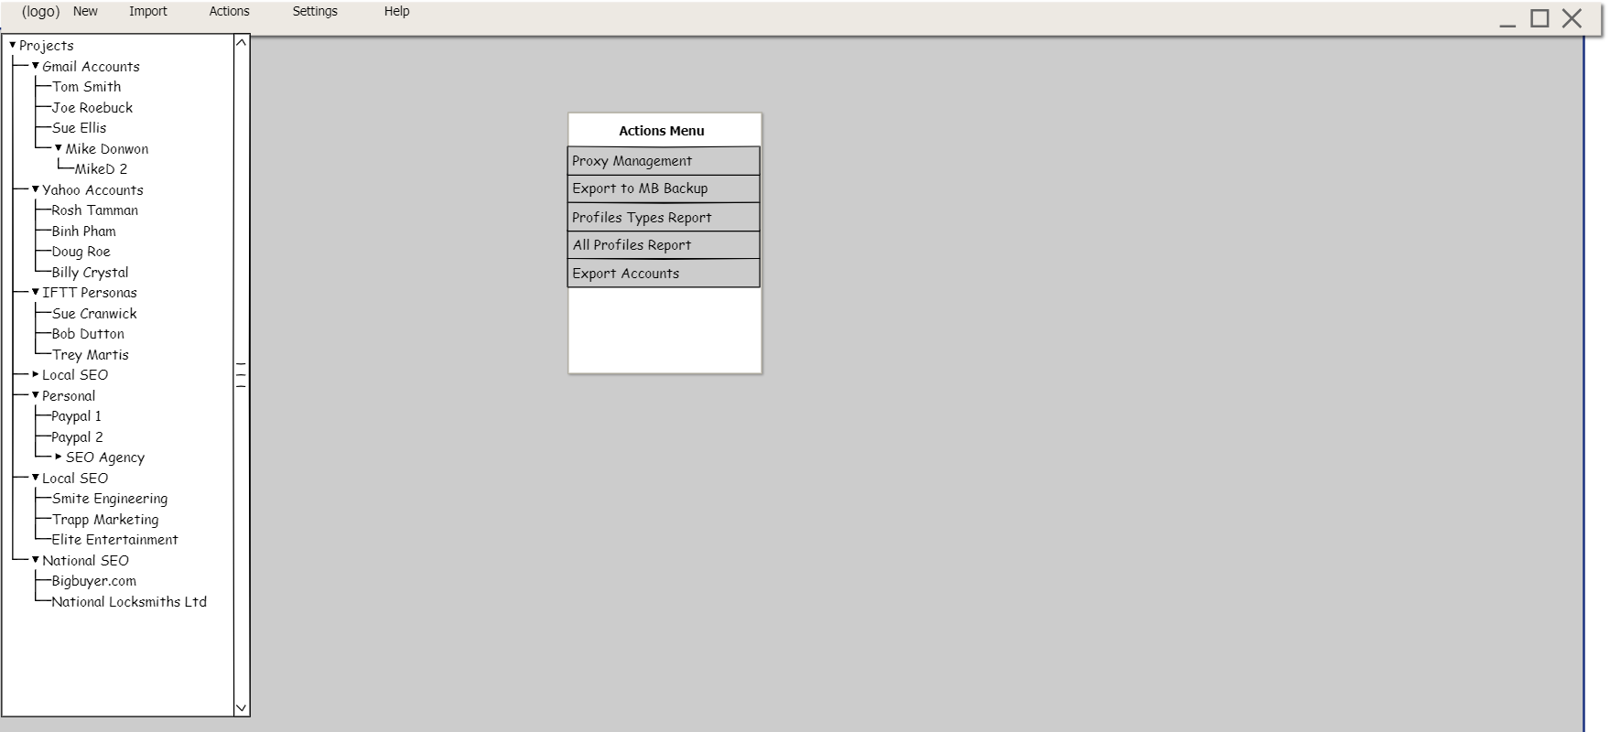

First menu item is proxy management, this is where newly uploaded proxies and assigned proxies show. (assigned meaning that they are in use on a project). So if new clean (not assigned) proxies are added to the system, they will show with the following values  
Profile Name – Default (null) Proxy IP address = the proxy IP, Port , username and password.  
User can then assign new proxies to profiles from here as well. 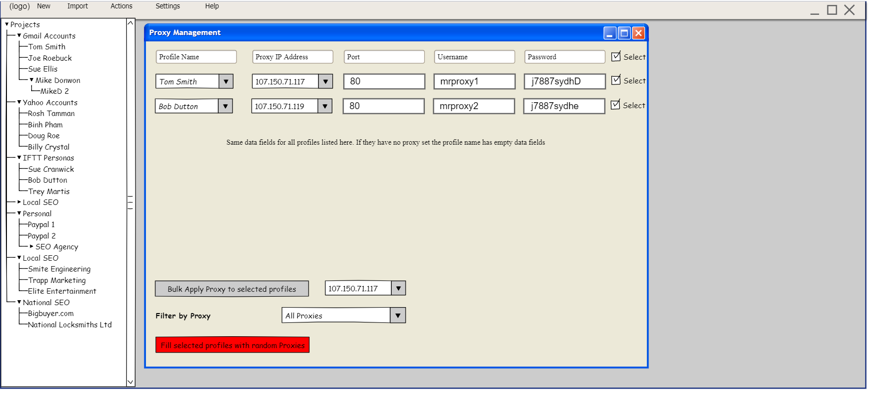

Export to MB backup – This exports the database tables into a CSV or Other file that can then be reuploaded into MultiBrowse to restore it. So it is a backup file that reloads the system with the data from all tables.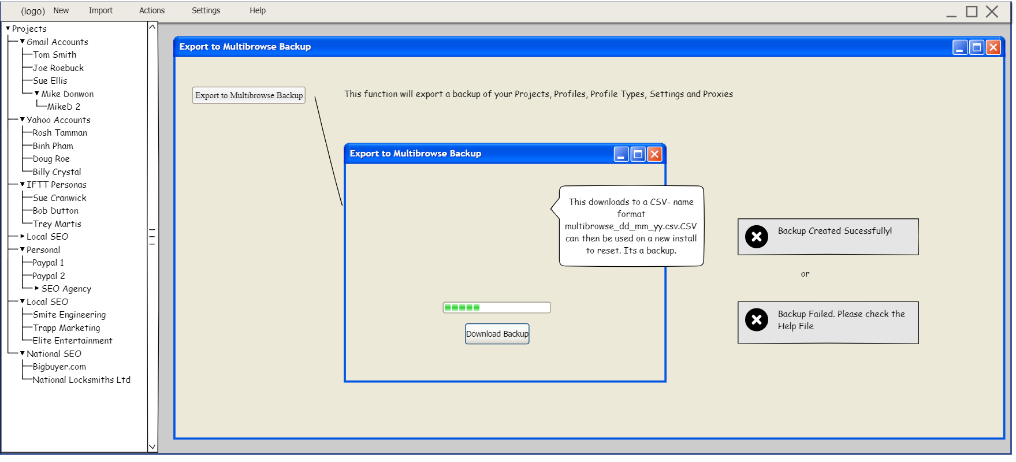

Profile Types Report- A Profile Type is just a field a user can create to GROUP the same types of profiles. For example Profile Type Facebook could be assigned to all of their Facebook Profiles. Under this report, it shows Profile Type > and the names of the profiles (personas) that have that profile type assigned.

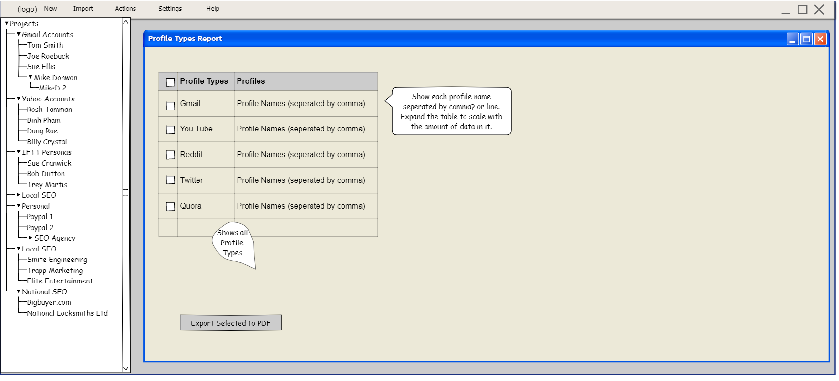

This shows summary of all Profiles (or whatever filters are applied) It can then be exported to a PDF report file **the selected ones or it needs ‘select all’ for the top tickbox in the heading, not just ‘select’ (will have MB logo at top left corner of all reports). I will supply this. Just use a holding image for now. Approximately 250 px tall x 400 px wide

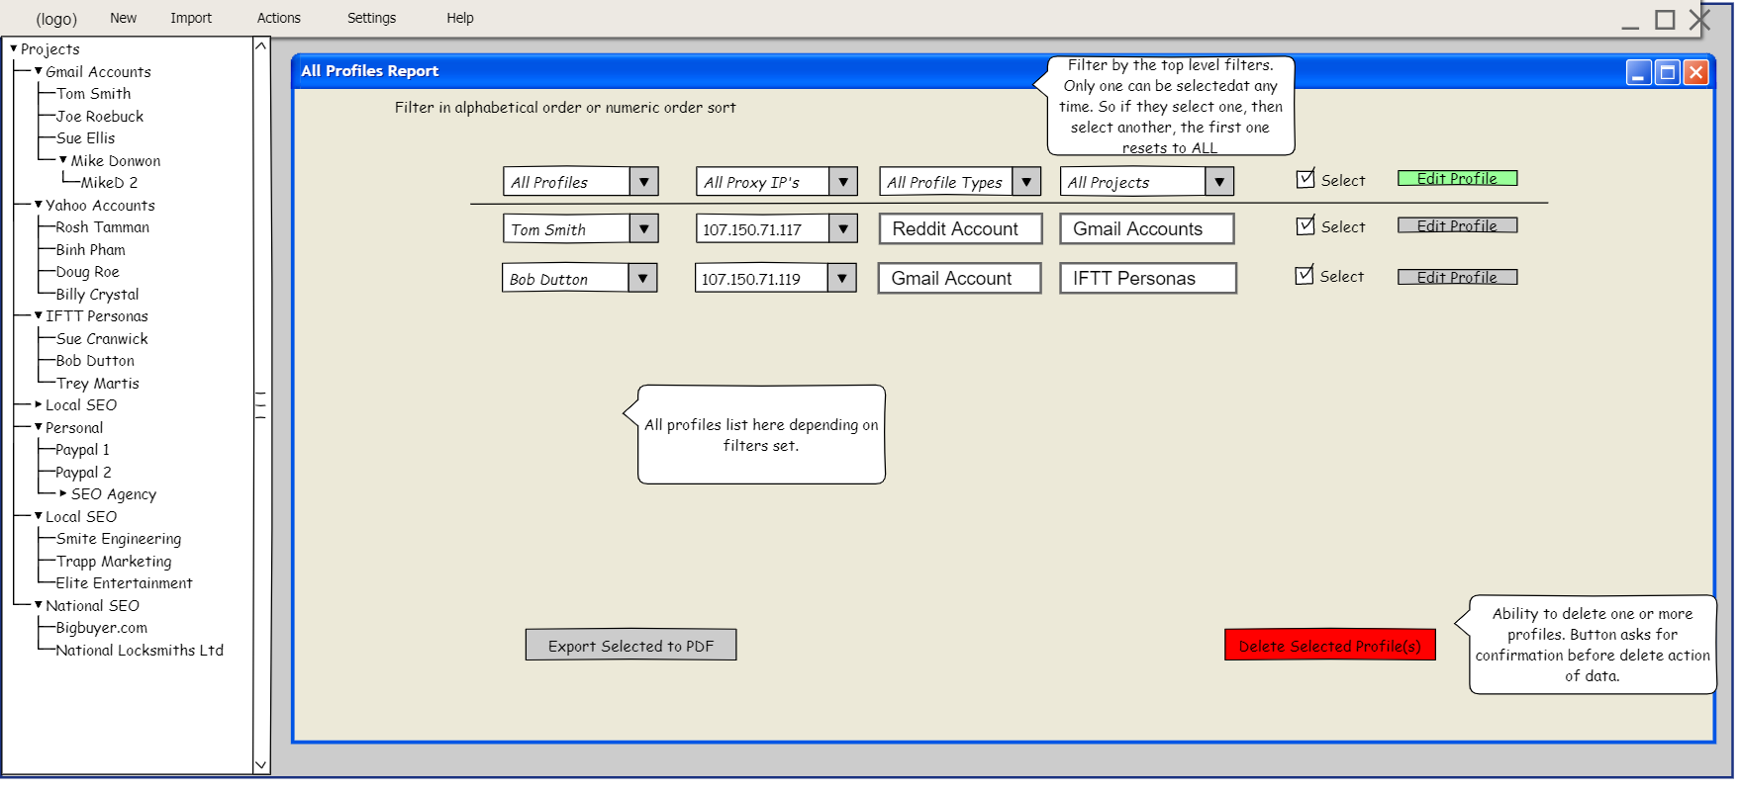

If user selects the profiles and clicks ‘Delete Selected Data’ It first shows a message , ‘ARE YOU SURE YOU WANT TO DELETE THIS PROFILE(S). If they click NO it returns them to the above screen, if they click YES it deletes the data and Shows the message below.

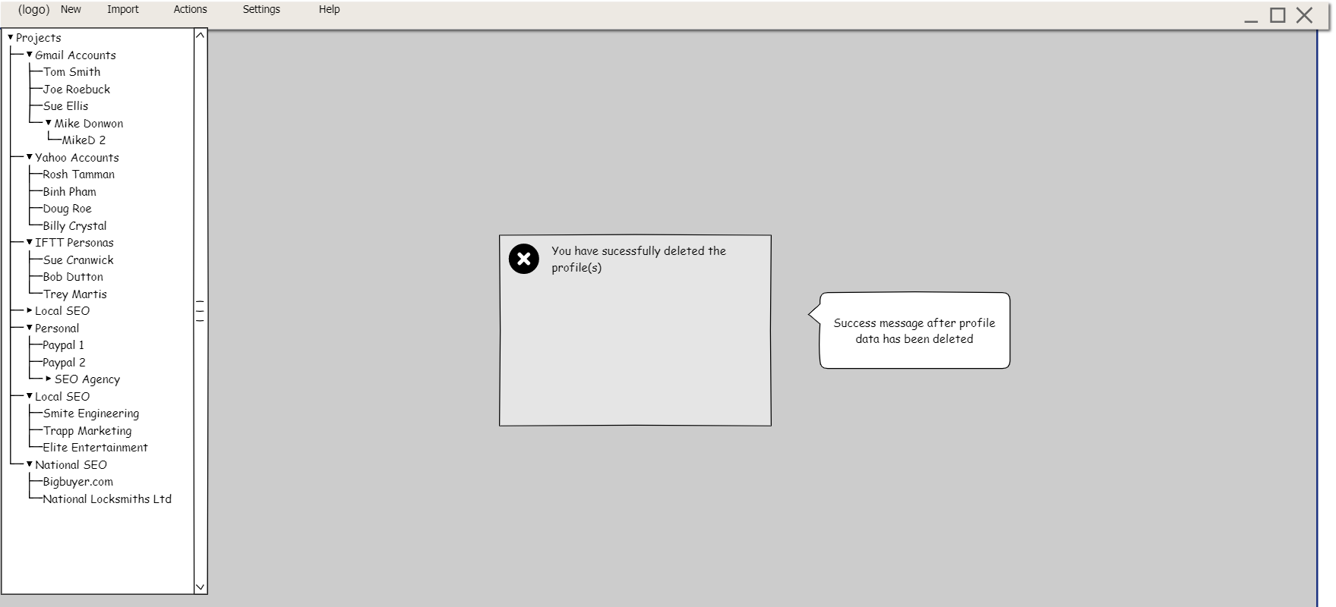

This export accounts function shows all Profiles and allows the user to select ALL or individual rows to export into a csv file. They can choose what fields should be exported. Default is to have ALL options ticked. This csv file can be then saved as a profiles backup. Which the user could reimport to another installation of Multibrowse if they didn’t wish to do a full Multibrowse reinstall (for example for a multiuser license ) .They would use the Import Menu > Import Accounts function to do this Import.

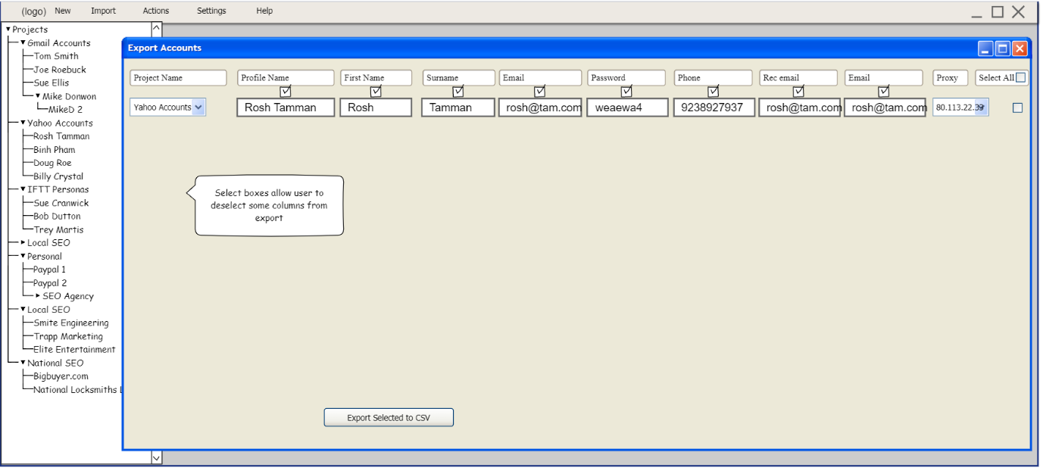

This is the settings Menu on the menu bar

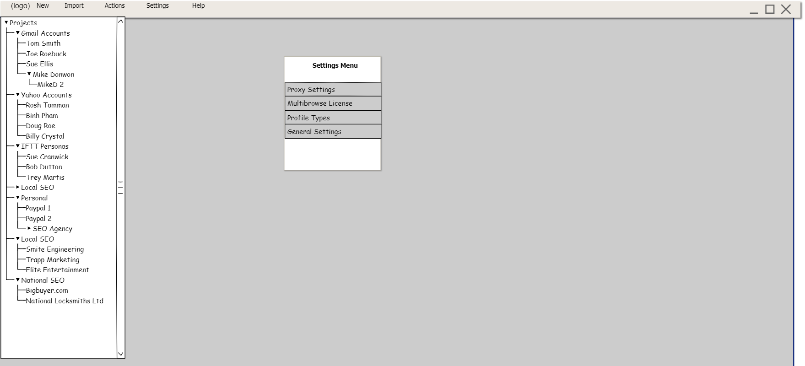

This is where the user can import a proxy csv file.   
Add proxy – adds just a blank row for each time they press it (auto saves)  
Import Proxies – see image below, import the CSV file and populate the Proxy table  
Delete proxies – show popup warning ‘You are about to delete this data’ If they click ok , remove proxies . Make profiles with no proxy just show a blank in the proxy listbox.  
Test selected Proxies – **Maybe we don’t have to add this, It would be cool to ping them to check they are working. Could add later.**

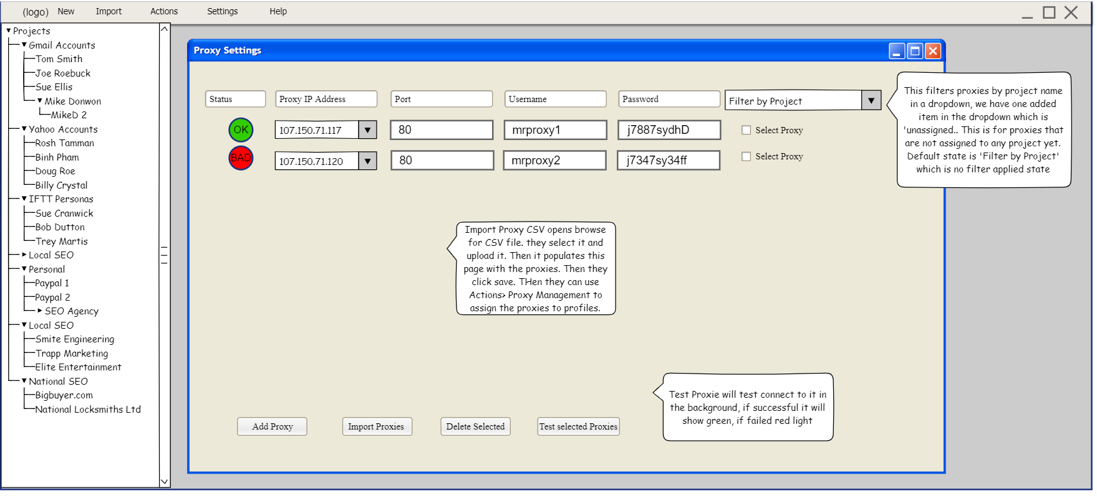

This shows when a user clicks ‘Import Proxies’

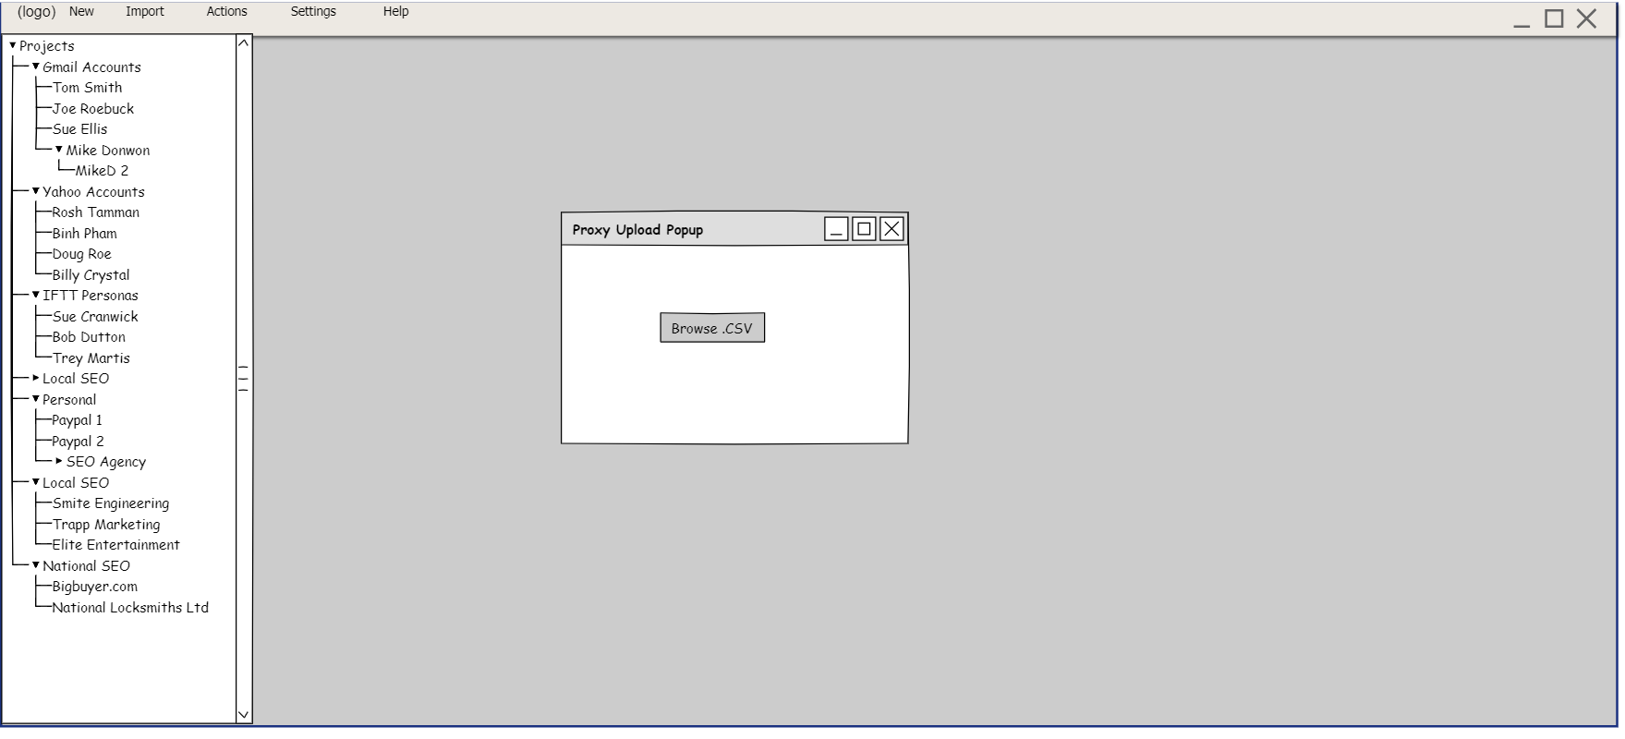

This shows the Multibrowse license that the user has, the information is passed on first running of the software, and validates when software starts. If license / subscription is not valid….the software will not run.

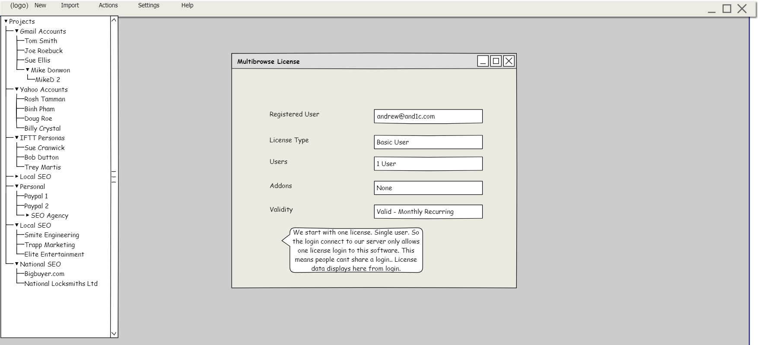

This is where user can choose what browser is launched for all double click actions, when they click on a profile in the project tree. Default setting is chrome.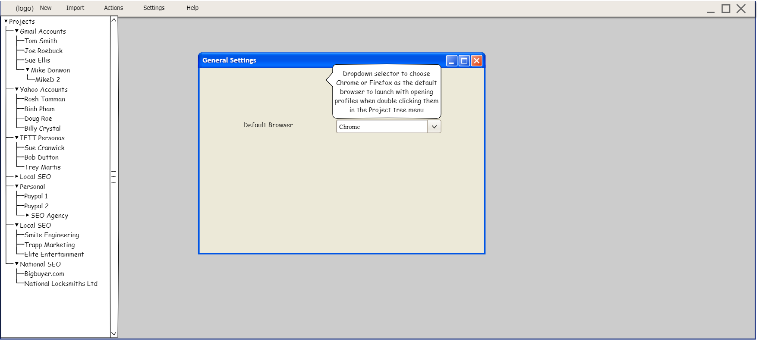

This is where user can add or remove profile types.

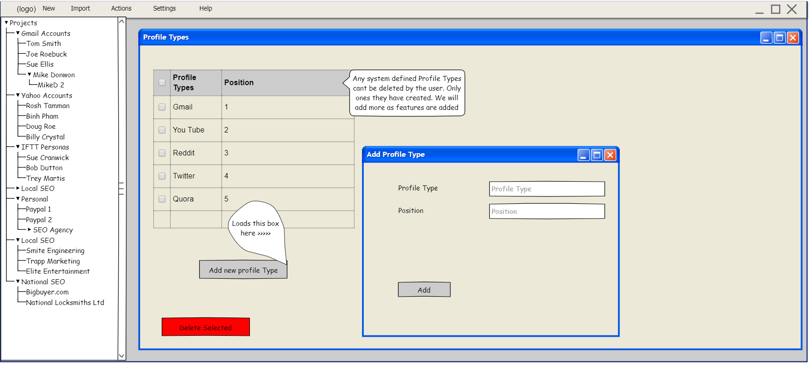

Help Menu is for helpfile. I will create this manual when we have a working product…!

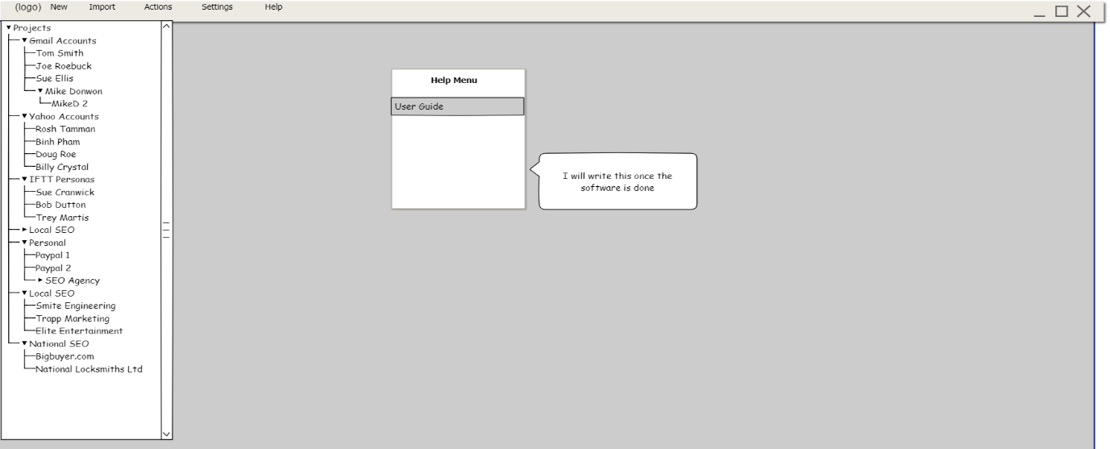

This is some user profiles opened in MB by a user who chose firefox for this. . Shows different tabs that hold those browser instances. Tabs can be closed with an X. If user closes all open Profiles, then all browser instances are closed when they click X on the profile tab. If all are shut down they return to main dashboard. The file tree on the left will expand or collapse so they can increase screen size of view their projects to open a different Profile.

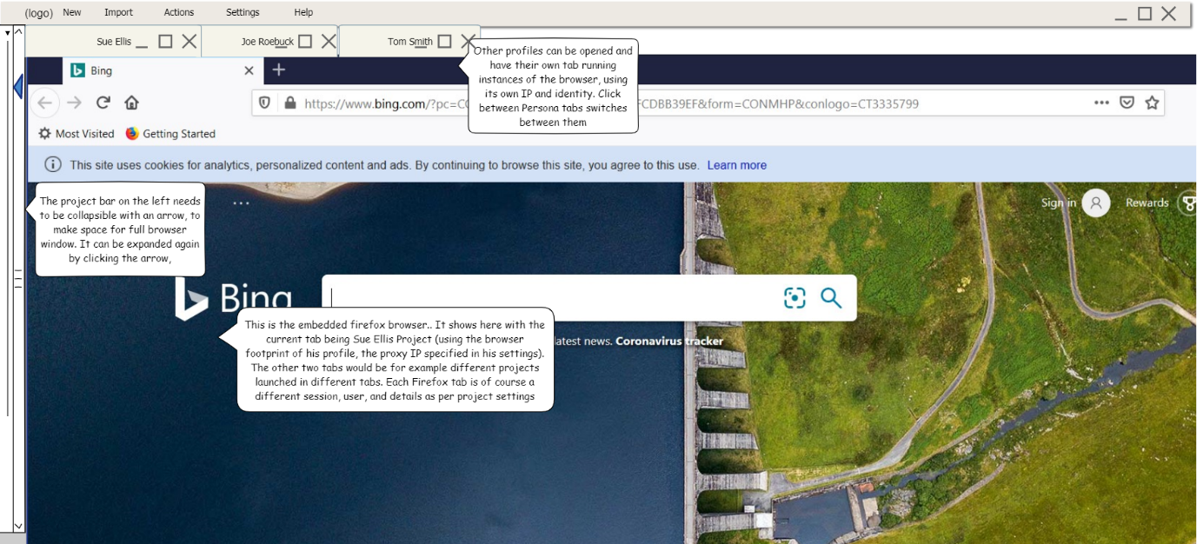

This is some user profiles opened in MB by a user who chose Chrome for this. . Shows different tabs that hold those browser instances. Tabs can be closed with an X. If user closes all open Profiles, then all browser instances are closed when they click X on the profile tab. If all are shut down they return to main dashboard. The file tree on the left will expand or collapse so they can increase screen size of view their projects to open a different Profile.

